Lift chart is used to show the lift data with respect to ideal data. It is commonly used for prediction models and how different models perform against each other.

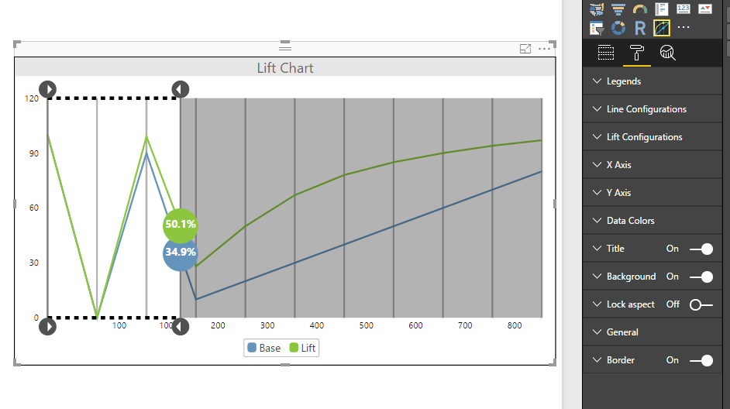

Configurations:

1. Legends:
   1. Enable: Show/Hide legends
   2. Enable click: Enable toggle on legends to select/deselect data points
2. Line Configurations:
   1. Step Line: To enable or disable step line  
      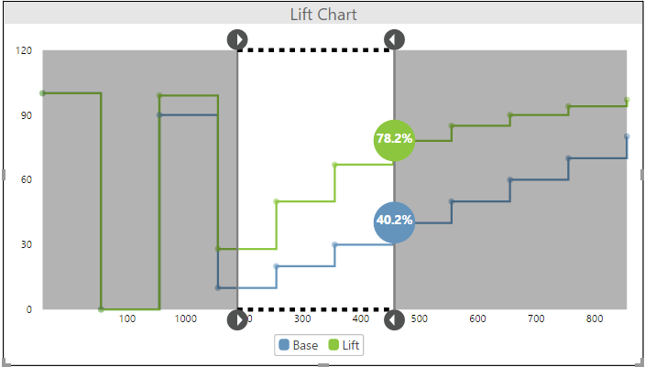
   2. Marker: Show/Hide marker points  
      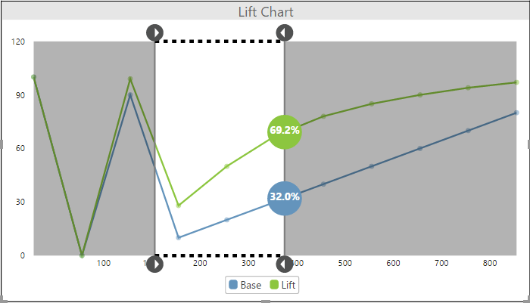
   3. Marker Width: Specify marker width
   4. Line Width: Specify ideal and lift line width  
      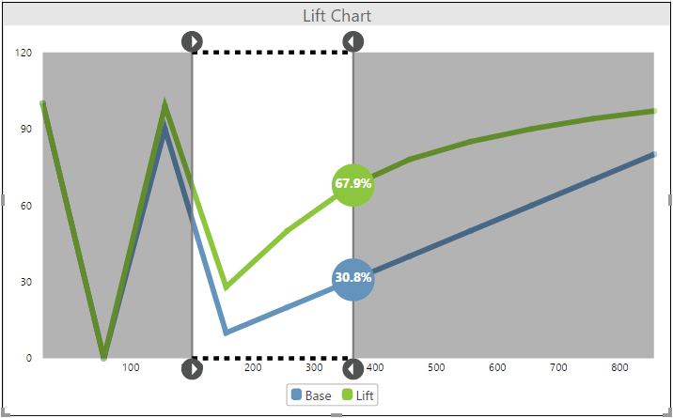
3. Lift Configurations:
   1. Drag Line Color: Select color of selected window line  
      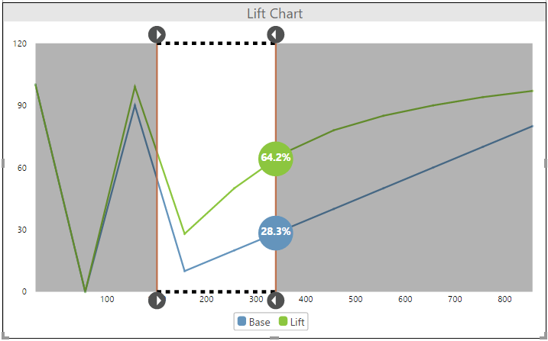
   2. Drag Line Width: Specify width of selected window line
   3. Bubble Text Color: Specify font color inside bubble  
      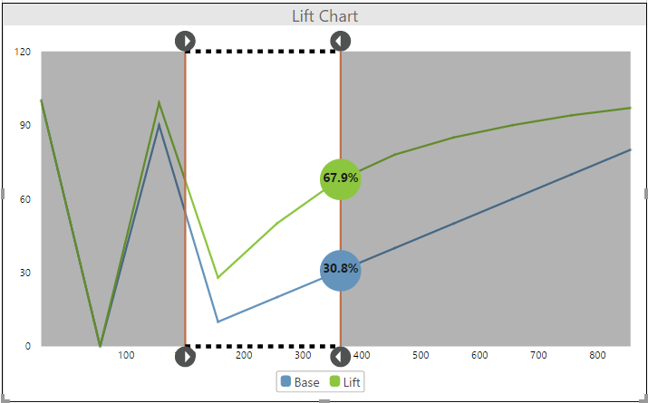
   4. Bubble Text Size: To set font size of bubble
4. X Axis:
   1. Enable Labels: Show/hide labels on X Axis
   2. Font Size: Specify font size of X Axis labels
   3. Grid Line Color: Specify grid line color on X Axis  
      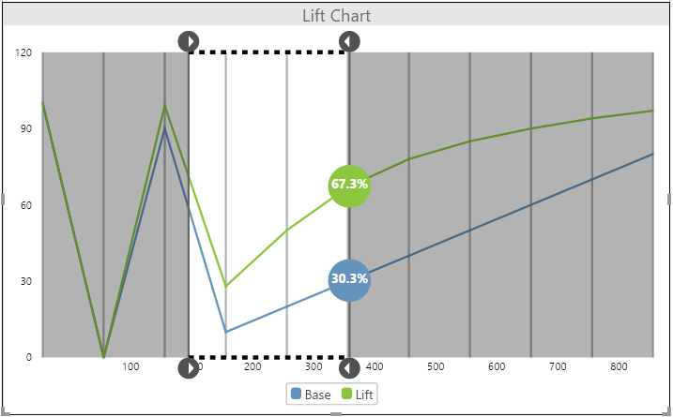
   4. Grid Line Width: Specify width of grid line on X Axis
5. Y Axis:
   1. Enable Labels: Show/hide labels on Y Axis
   2. Font Size: Specify font size of Y Axis labels
   3. Grid Line Color: Specify grid line color on Y Axis   
      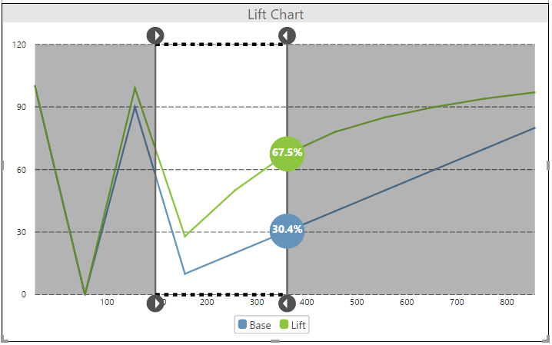
   4. Grid Line Width: Specify width of grid line on Y Axis
6. Data Colors: To set colors of lift and ideal lines